Day 4 : 15 Oct 2024 CB FSD - Planning and UI Design

SDLC : Software Development Life cycle : SDLC is structured process used to design, develop and test high quality software.

Planning :

* Understand the project or application or app goal, scope, requirement and constraints.
* Cost, timeline and resources etc.

Requirement gathering and Analysis :

* Collect detailed software requirement from stakeholder.
* Document and analysis these requirement to ensure feasibility.

Design

* Convert these all requirement into blueprint for the system architecture. Flow chart OR UML
* Define database design (ER-Diagram) , user interface and software component.

Development

* Actual coding base upon the design using different language.
* Developer need to write the base upon standard design pattern.

Testing

* Test the software to identity the error and fix the bugs.
* Ensure that the software meet all functional as well as non functional requirement base upon client.

Deployment

* Release the software or application to the production environment.
* The software is installed and mode available for use.

Maintenance

* Monitor the software or hardware issue and provide the support.
* Handle update, patch and improvement. etc.

SDLC Model :

1. Water fall model
2. V model
3. Increment model
4. Spiral model
5. Agile

Water fall model : A sequence development process with clearly defined stages or each phase. Each phase must be completed before moving to next phase (no overlap).

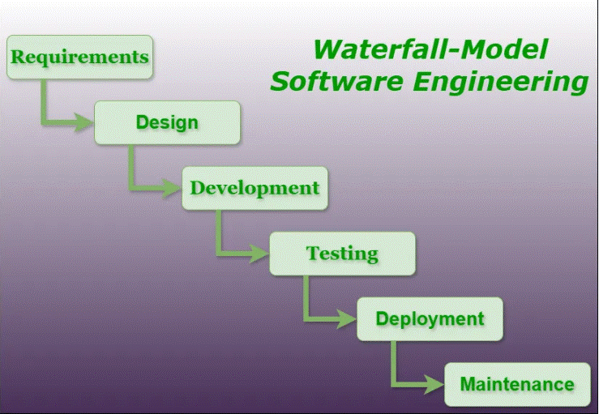

Agile : Agile is a software development approach and project management philosophy that emphasizes flexibility, collaboration, customer feedback, ready to do any changes base upon client requirement continues delivery etc.

1. An iterative and incremental development process.
2. Development is done in short cycle called sprint (2 to 4 weeks).
3. Each sprint result in a working software increment that can be revived, tested and improved upon.
4. Focuses on flexibility and continues feedback from client or stakeholder.

Agile Manifesto principles

1. Individual and interaction over process and tools.
2. Working software or application over comprehensive documentation. V model
3. Customer collaboration over contract negotiation.
4. Responding to change over following a plan.

Rest api or micro service using micro service we can develop our application using any language on demand.

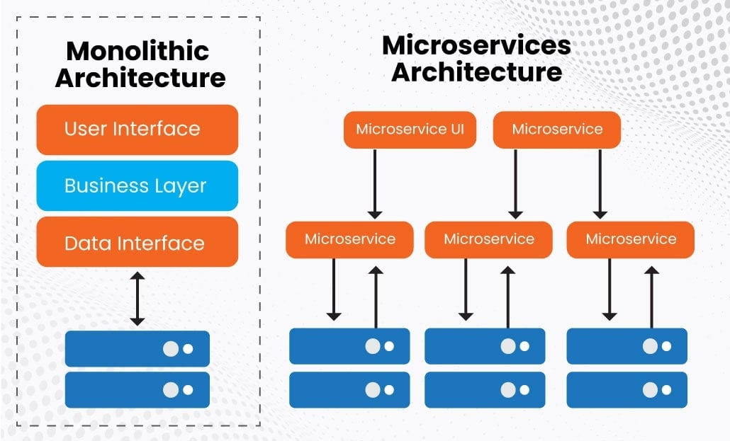

Agile is a concept. To implement agile concept we need to take the help of framework.

Agile framework

1. Scrum
2. Kanban
3. XP (Extreme programming)
4. SAFe

Etc

Scrum : Scrum is a one of the implementation of Agile concept. Scrum help us to work in team together to develop and deliver complex project or application. It use specific terminology to describe the roles, events and artifact.

Scrum Roles

1. Product Owner
   1. Responsible for defining product features and prioritizing them.
   2. Act as the voice of the customer, bridging the gap between shake holder/customer and strum team.
   3. Manage the Product backlog (A product backlog is a prioritizing list of work or features that a product team need to deliver to achieve the product vision).
2. Scrum Master
   1. The scrum master play critical role in scrum team, acting as a facilitator, coach, and servant leader to ensure the effective implementation of the scrum framework.
3. Scrum Team
   1. A group of people (developer, tester, admin designer, UI developer etc) responsible to delivering a task or project.

Scrum Terminology:

User Story :

* A short, simple description of a features or requirement from the perspective of the end user or customer or shake holder.
* Each story helps to defined what need to be built and its size is estimated using story point.

Epic

* A large high level user story that can be broken down into smaller, more manageable user stories.
* Epics usually span in multiple sprints.

Burn – Down Chart

* A visual representation of the amount of work remaining in a that sprint.
* It shows progress by comparing the team’s work completed with time left, helping track that sprint goal is achievable.

Scrum Events

**Sprint**

* A time boxed iteration (2 to 4 week), where the team work on set of product backlog or features.
* Each sprint aims to produce working product software or features.

Sprint planning

* A meeting held at the stat of a sprint where a team plan and decide what tasks to complete from the product backlog and how to achieve
* The product owner presents the most important item or features and the team select that they can commit to completing

**Daily Scrum meeting**

* A 15-minute meeting where the team discuss
  + What they worked on yesterday
  + What they plan to do today
  + Any obstacles or blocker they are facing

E-Shopping App

User Story

1. I need for my application login page
2. I need different type of user like admin, manager or customer
3. I need app to do the payment
4. I need app to do product related operation
5. I need app to keep the track about the orders

**Jira tool:** this tool help us to create the Project which contains more than one user stories and epics.

In Jira account we created

E-Shopping App Project

Epics

1. Type of User Account Management
2. Product catalog
3. Order management
4. Shopping Cart
5. Payment integration

Now we will create User